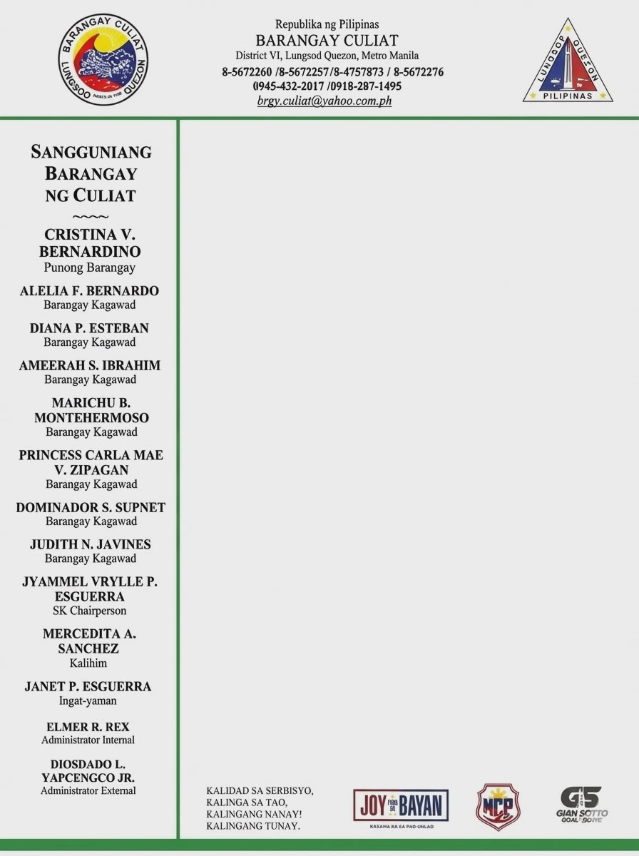

CERTIFICATION

TO WHOM IT MAY CONCERN:

This is to certify that {salutation} {full_name}, Filipino, of legal age, with postal address at {full_address}, Barangay Culiat, Quezon City, is a bona fide resident of this barangay.

This further certifies that the above-said person is requesting the assistance of your good office in the rehabilitation of his/her {beneficiary_relationship}, {beneficiary_name}, {beneficiary_age}, born on {beneficiary_date_of_birth}, who is under the influence of drugs and belongs to the indigent families living in this barangay.

This certification is issued upon the request of {salutation} {full_name} for {purpose_of_request}.

Issued this {issue_date} in Barangay Culiat, District VI, Quezon City.

